Set Tayo Ng Date
Use Case Diagram

Submitted to:

Prof. Ma. Rowena C. Solamo
Faculty Member
Department of Computer Science
College of Engineering
University of the Philippines, Diliman

Submitted by:
Bandong, Arvin
Bariring, Edward James
Rosales, Kyle

In partial fulfillment of Academic Requirements
for the course
CS 191 Software Engineering I
of the
1st Semester, AY <2016-2017>
Unique Reference:
The documents are stored in the https://github.com/DarkPotatoKing/cs-191-192-repo
[File Reference in GitHub, preferably link.]

Document Purpose:
[What is the purpose of the document?]

Target Audience:
[Place here the target audience.]

Revision Control

History Revision:
Revision Date | Person Responsible | Version  Number | Modification
09/24/16 | Kyle Rosales | 1.0 | Initial Document

System Name: Set Tayo Ng Date

Description: This software allows people in a group to input their schedules into the
software's database. It is a tool to help people set meetings when everyone
in the group is free by displaying everyone's schedules. It also has advance
search options which lets you answer questions like "When is Alice, Bob,
and Charlie free between 10 am and 2 pm?

Use-Case Diagram:

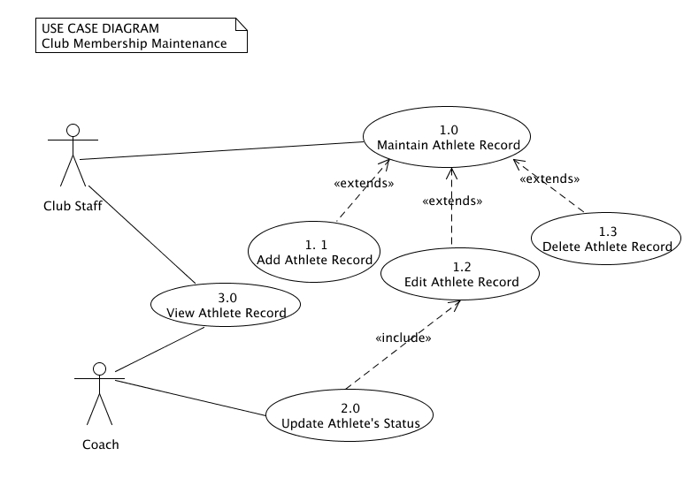

Place here the Use-Case Diagram. Make sure that the diagram is grouped as one and text does not wrap around the diagram.

List of Actors:
Actors | Description
Staff | [Write the description of the actor. 3-5 sentences]
Coach | [Write the description of the actor. 3-5 sentences]

List of Use-cases:
Use-Case | Description
Use-Case 1.0 Maintain Athlete Record | [Write the description of the actor. 3-5 sentences]
Use-Case 1.1 Add Athlete Record | [Write the description of the actor. 3-5 sentences]

